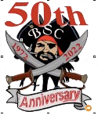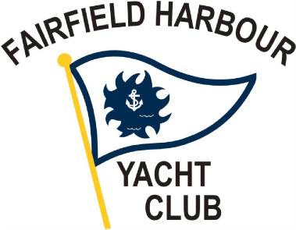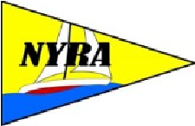
2022 Neuse River Regatta Notice Of Race
AMENDMENT #1

NoR Item 5 is hereby amended as appears in bold below:

5 SCHEDULE
5.1 There will be a skipper’s meeting at 0930 at BSC.
5.2 One race is scheduled the first signal for which will be at 1055 on Saturday, October 1, 2022.
5.3 It is intended that there will be a social and dinner after the racing at Blackbeard Sailing Club, 1215 Barkentine Drive, New Bern 28560 at 1700. The dinner will go on even if racing is cancelled.

POSTED: 09/17/2022 by the OA

